SUSE 9.2
Shell – Console: (To add a printer user)
- Enter root
- Create a user
lppasswd –a name
Then set a password.
- Check printer user in
/etc/cups/passwd.md5

On SUSE window:
Start → Utilities → Printing → Printing Manager
Print system currently used: CUPS(Common Unix Print System)
Add → Printer/Class
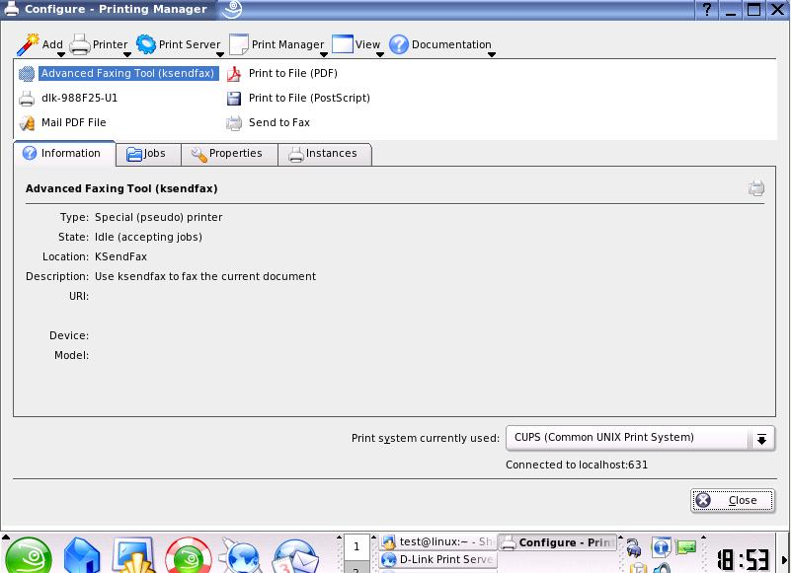

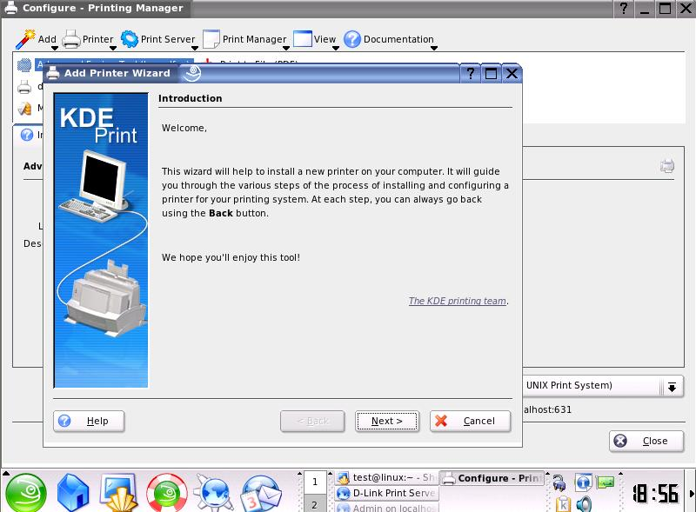

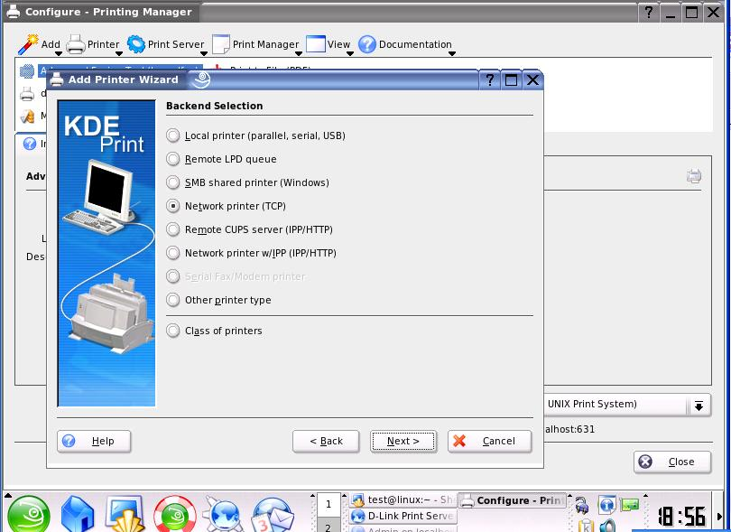

Port: USB1→ 9100, USB2→9101, LPT→9102
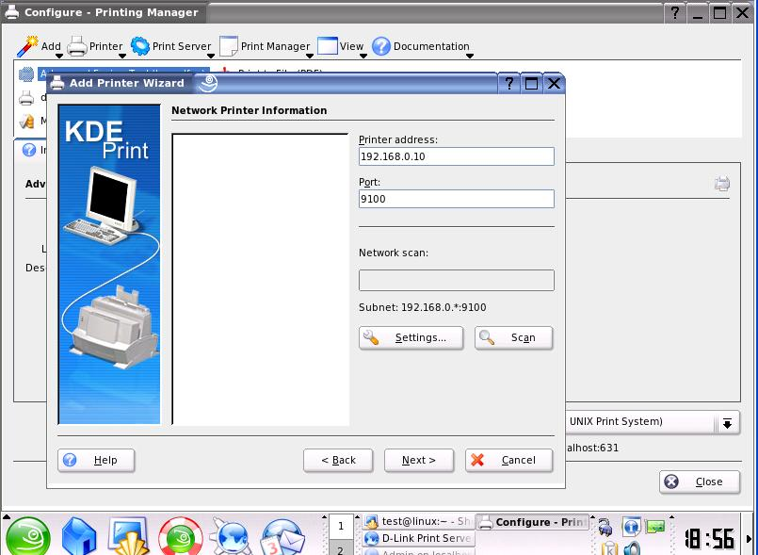
Please select correct printer.
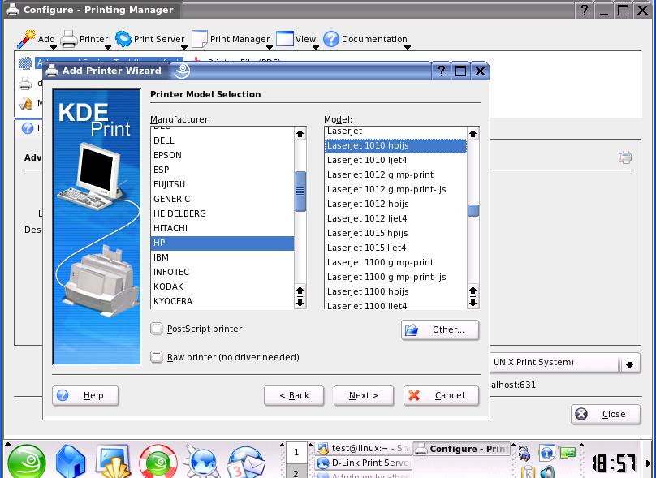
Then follow the KDE setting till finish.
When you want to print document, SUSE will ask you the username and password, please use the print account you set at Step 2. (you set on Console)

