VPN L2TP Application
Installation Guide

Configuring a Remote Access L2TP VPN Dial-in Connection

A remote worker establishes a L2TP VPN connection with the head office using Microsoft's VPN Adapter (included with Windows XP/2000/ME, etc.). The router is installed in the head office, connected to a couple of PCs and Servers.

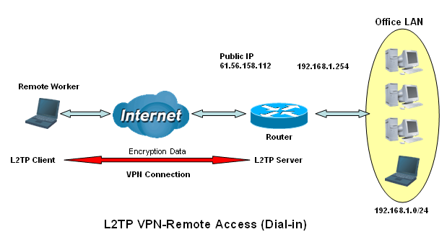
Dial-in

Configuring L2TP VPN in the Office

The input IP address 192.168.1.200 will be assigned to the remote worker. Please make sure this IP is not used in the Office LAN.

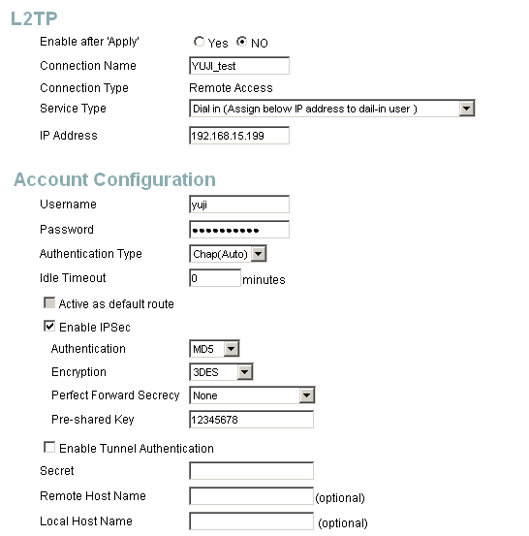
1
4
3
2
5
6

Item | Function |  | Description
1 | Connection Name | YUJI_test | Given a name of L2TP connection
2 | Dial in |  | Check Dial in
2 | Private IP Address Assigned to Dialing User | 192.168.15.199 | An assigned IP address for the remote worker
3 | Username | yuji | Input username & password to authenticate remote worker
3 | Password | 123456 | Input username & password to authenticate remote worker
4 | Auth.Type | Chap(Auto) | Keep as default value in most of the cases.
5 | Idle Timeout | 0 | The connection will be disconnected when there Is no traffic in a predefined period of time. Idle time 0 means the connection is always-on.
6 | IPSec |  | Enable for enhancing your L2TP VPN security.
6 | Authentication | MD5 | Both sites should use the same value.
6 | Encryption | 3DES | Both sites should use the same value.
6 | Perfect Forward Secrecy | None | Both sites should use the same value.
6 | Pre-shared Key | 12345678 | Both sites should use the same value.
Configuring Remote Worker for Dial-out to the Router

Step 1  Select “New Connection Wizard” to create a VPN-L2TP dial out service. | 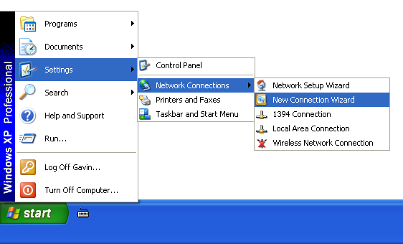
Step 2  Click Next > to the next step. | 
Step 3  Check “Connect to the network at my workplace” radio button.  Click Next > to the next step. | 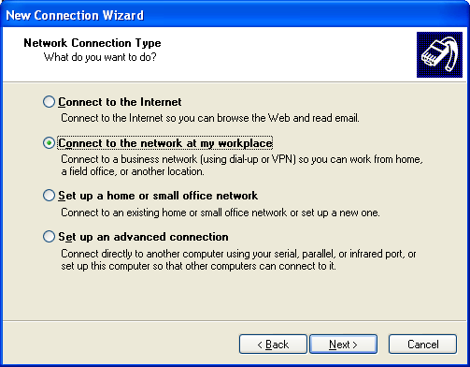
Step 4  Check “Virtual Private Network connection” radio button.  Click Next > to the next step. | 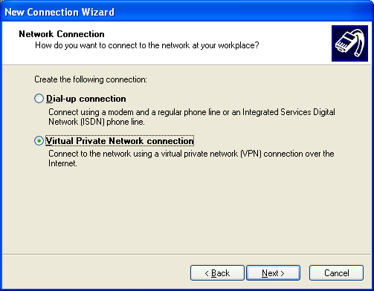
Step 5  Give a name to the L2TP connection.  Click Next > to the next step. | 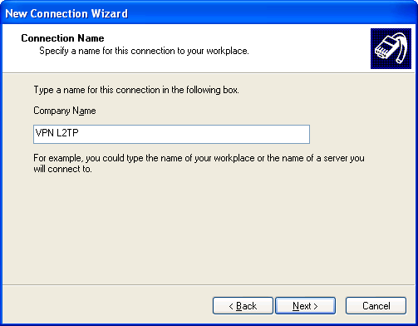
Step 6  Input VPN-L2TP Server’s IP address. You can use Host name, only if the DDNS function is enabled in the Router.  Refer to the user manual for more detail.  Click Next > to the next step. | 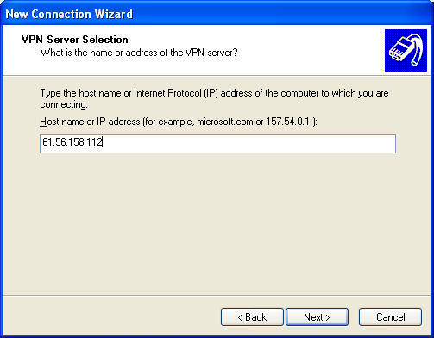
Step 7  Click Finish to the next step. | 
Step 8  Open Network Connections and double click on the VPN L2TP icon. | 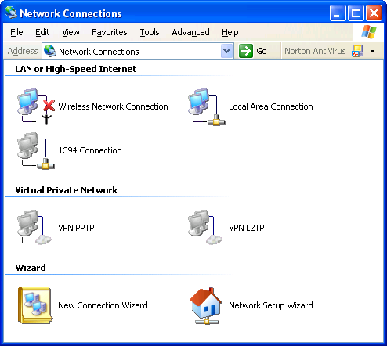
Step 9  Select “Networking” tab, and change “Type of VPN” to “L2TP IPSec VPN”. | 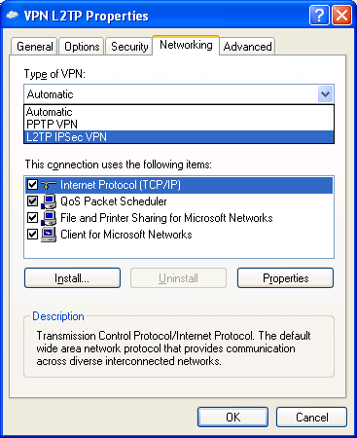
Step 10  Select “Security” tab.  Click IPSec Settings… to the next step. | 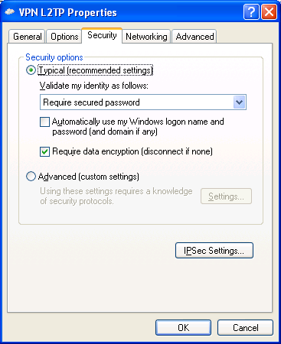
Step 11  Input pre-shared key.  Note: This pre-shared key must be identical as set up in the Router.  Click OK to the next step. | 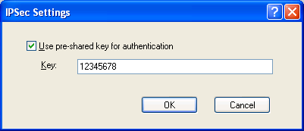
Step 12  Click OK to continue. | 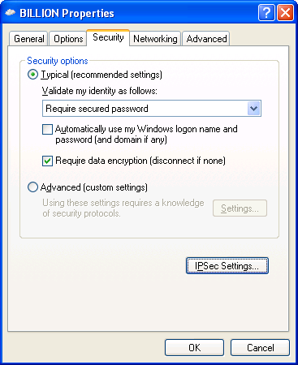
Step 13  User name and Password should be identical as set up in Router. (See Item 3)  Click Connect to establish a connection to your VPN-L2TP Server.  Completed! | 