DWM-152 install on Mac OS
Before you install the software, you must first install a SIM card into the USB adapter and connect the adapter to a USB port on your computer.

Mac hardware overview.
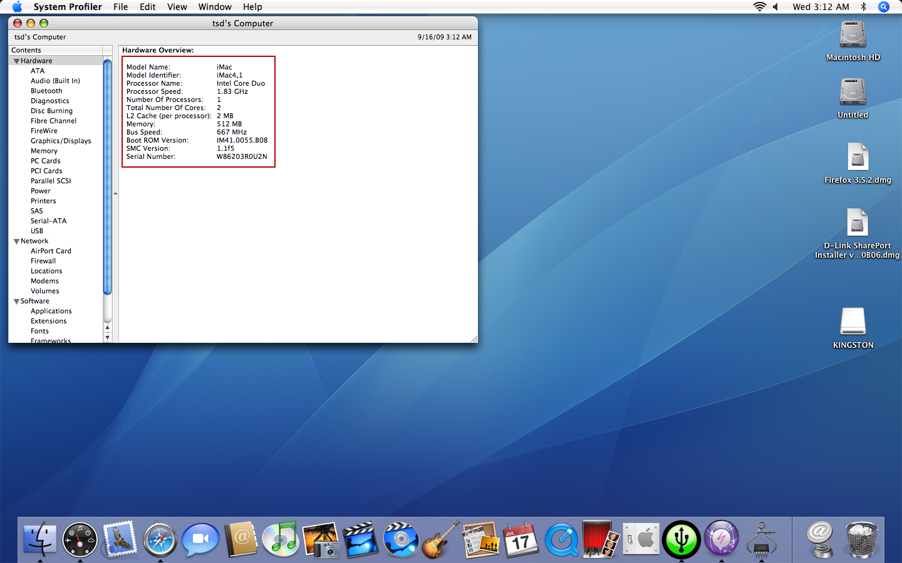

Mac OS version.
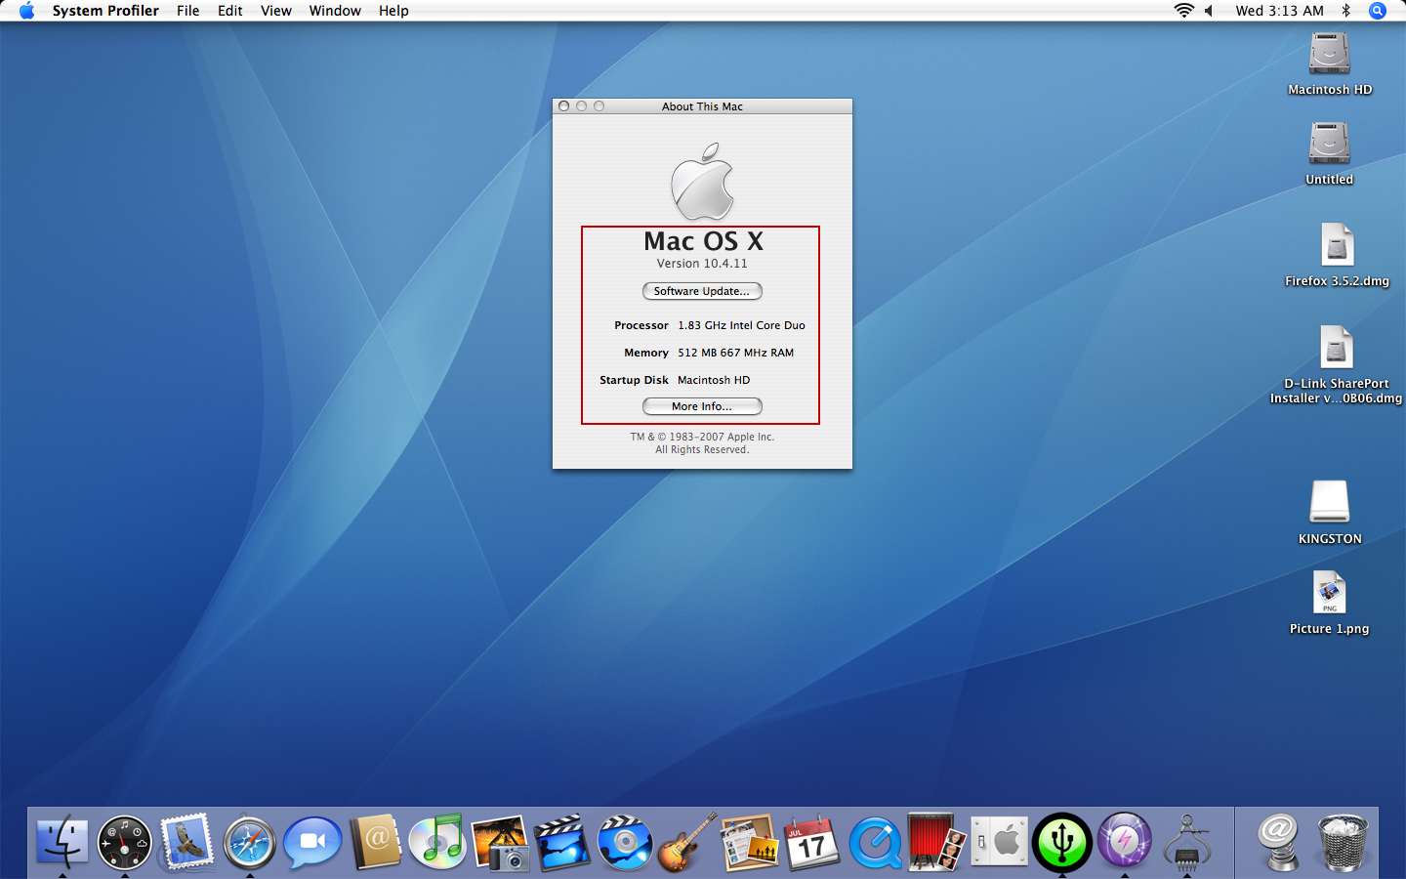
Desktop appear USB device after plug the DWM-152 into a USB port on your Mac computer.
Entered into CONNMGR device.
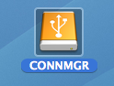

Double click Mac folder.
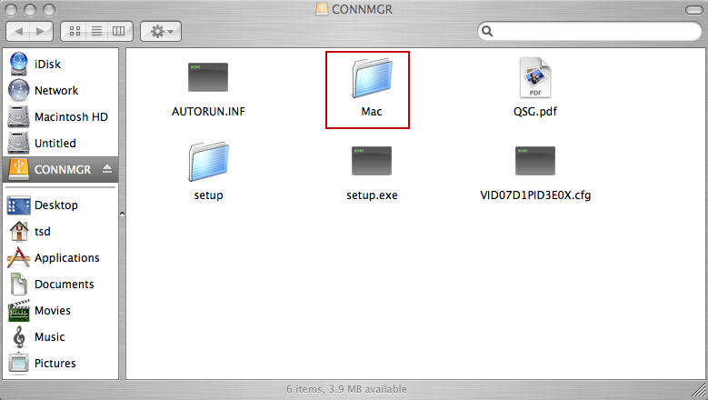

Copy the file Mac_AP_Release.zip to Desktop and unzip.
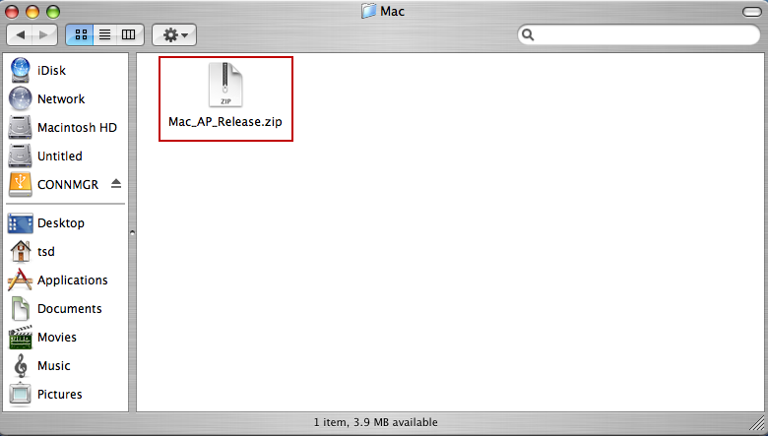

Double click the file D-Link USB Modem Application and Driver Package.mpkg to install software.
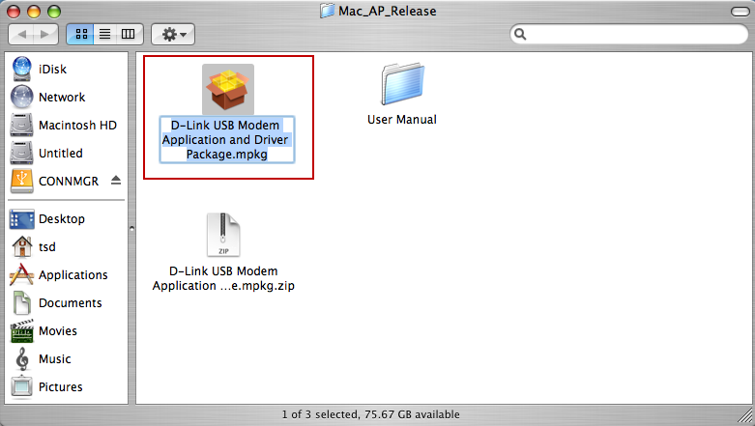

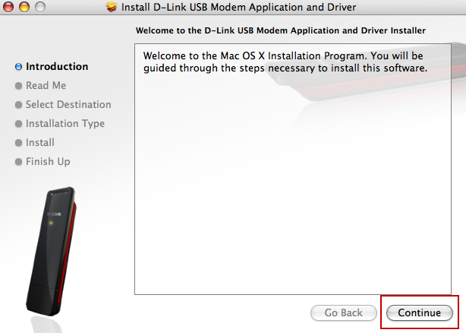

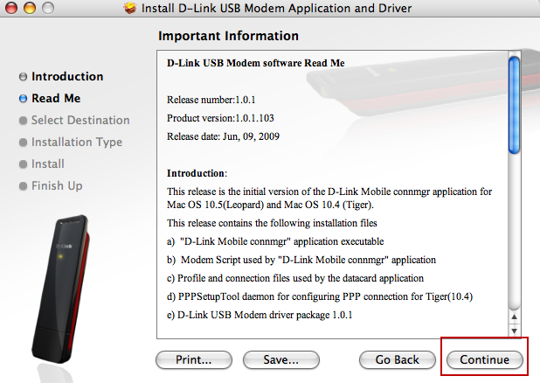

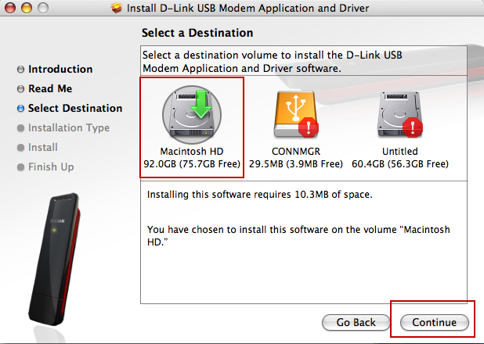

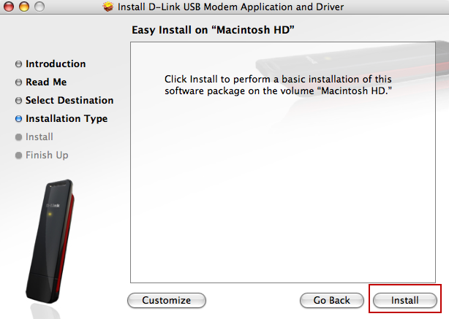

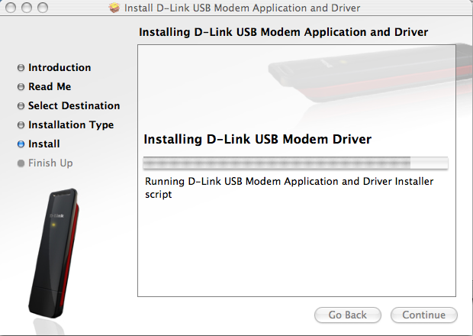

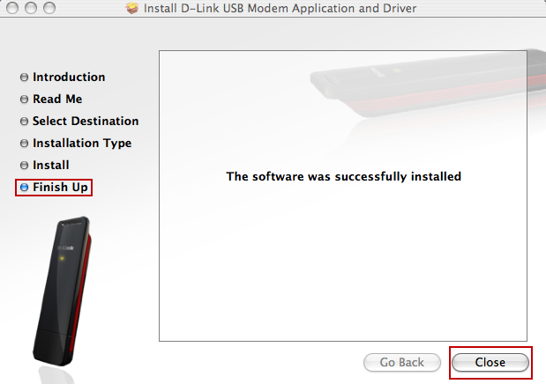

After software and driver installation finished, you will see the D-Link utility on desktop tool bar.

