How to update SW by upgrade tool for DWM-152/ 156
- Please keep the original installed DWM-152/ 156 Connection Manager in your PC.

- Plug-in DWM-152/ 156 to the USB port of your PC and wait for the driver/SW ready. Then double-click upgrade tool and press Next to start.
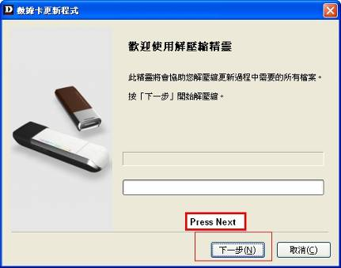

- Press Next
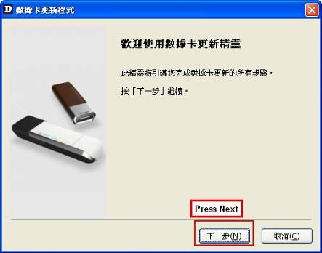
- Press Start to go on.
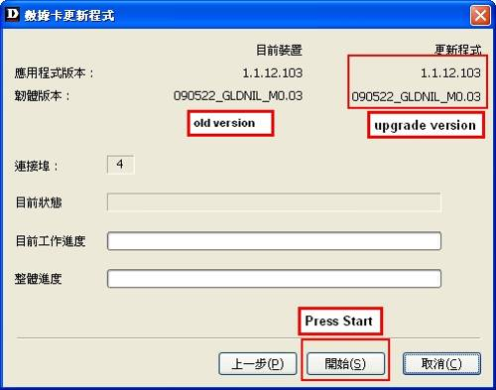

- Driver loading.
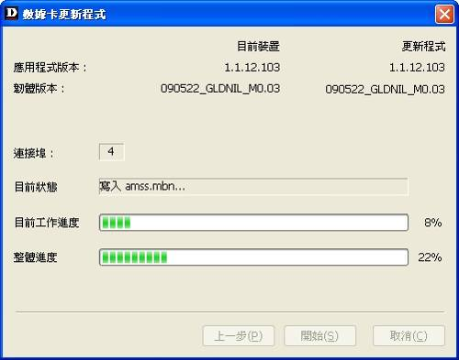

- Finish driver loading.
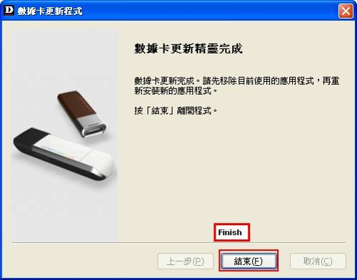

- After driver/SW upgrade is finished, your DWM-152/ 156 is integrated with new CM..
- Uninstall D-Link Mobile Connection Manager previously installed in your PC, then plug DWM-152/ 156 again to re-install the new CM.

9. Execute DWM-152/ 156 Mobile ConnMgr and check the utility version (v1.04) and driver version(091209_GKDNIL_M0.22 ) is the new version. The latest version will be updated accordingly.

